ISE 1 PAPER

Que 1.
a.
Soln. > If a variable is declared outside any funtion but inside a class, JVM will assign value to it if it is not initialised. But inside a function/method it need to be initialised.
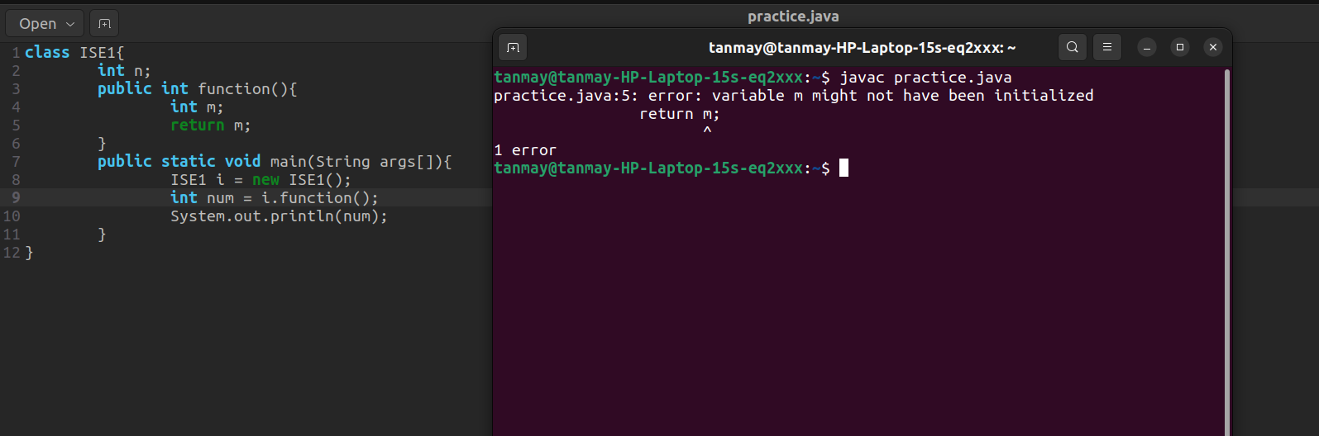

Que 1.
b.
Soln > To check if it is valid or not we can use .subString(); function.
Since, we know substring from index 4 , 7 must be bit .
So, we can write substring(4 , 7).equals(“bit”);

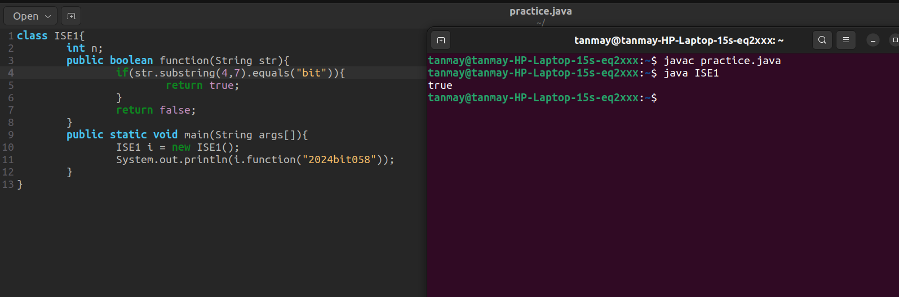

Que 2.
a.
Soln> If we make any variable or funtion static then we can access teh without need to create an instance of the class. They cannot access non-static members of class directly.

Que 2.
b.
Soln> line 6
At line 6 there will be no error since we can use wrapper class as variable names. And since String has no value then it will give output null.

Line 8
it will provide no error, we have to convert int 2024 to short so,
Since, we wnt to typecast it to byte to mod the number with 256.
2024 % 256
232
232 – 256
-24

